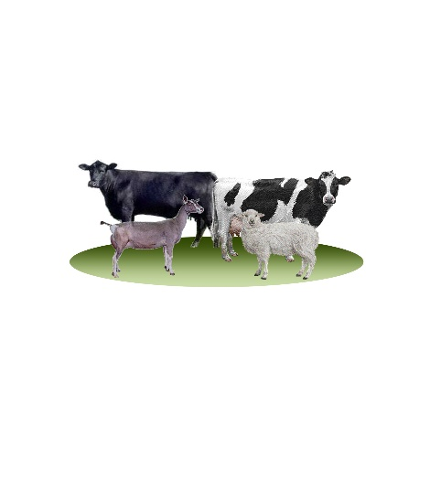
Louisa Veterinary Service, Inc.
P.O. Box 492
Louisa, Virginia 23093
Phone: 540-967-2974
Fax: 540-967-7271
louisa@gmail.com
www.louisavetservice.com

Theileria Update October 2020- The Struggle is Real

- What is Theileria?

- It is a blood-borne parasite transmitted to cattle by ticks.

- The type we are seeing in Central VA is Theileria orientalis.

- What kind of tick and how did it get to Central VA?

- The East Asian or Longhorn tick came to the U.S. from Asia in 2017 and was discovered in Albemarle County in the fall of that year.

- The ticks are quite small and extremely prolific, one female can have 3,000 babies with no male required.

- You could have this disease on your farm and have never seen the actual ticks OR you could see hundreds of thousands of them.

- If you find a tick(s) you would like identified contact your local veterinarian, extension agent, or the veterinary school. 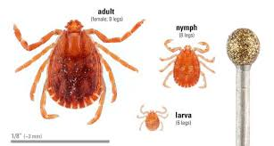

- Who is the tick causing problems for currently?

- Officially the tick has been found in 15 states, but is only causing problems for the cattle in 2 states, Virginia and West Virginia.

- Theileria is now in over 25 counties in Virginia and 4 counties in West Virginia.

(Maybe a picture of the map of VA here? If you have a current oe

- What months are transmission of the disease most common?

- Most cases are seen March-June, which could cause the Spring calving cows to have trouble getting re-bred; and September-November, which can make the fall-calving cows have major health problems around the time of calving.

- Experts say the tick seems to be very efficient at transmission; cattle get sicker much faster through a tick bite than through blood transmission.

- What are the symptoms of Theileria?

- Anemia resulting in slower movement, exercise intolerance, and/or weakness; some cows wobble or are unable to stand for long periods of time

- Anemia also results in pale or yellowing tissues (eyelids and inside of the vulva are good places to check)

- Poor appetite

- Decreased milk production

- Sudden death in late pregnancy or early lactation

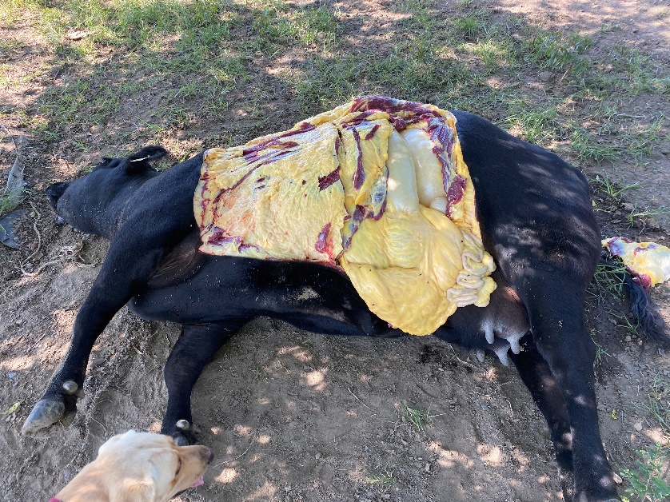
*Take note of how yellow the cow’s fat is, you can easily assess this in the field with a pocket-knife

*This picture is showing how yellow/orange a sick cow’s serum is and how few red blood cells are present (they are in the bottom of the tube)

- What age cattle are most at risk?

- Cattle can be affected at ANY age.

- The most commonly affected are geriatric cattle and calving and post-partum cows.

- Calves of these infected cows are often stillborn, however, they can be born very weak and die within a few days.

- Some Albemarle county farmers, from the index herds of the disease, note that their calves averaged lower weaning weights and appeared unthrifty when Theileria first hit their herds.

- In one research study of an infected farm, every calf in the herd at every age tested positive for Theileria.

- Can humans or other species get any diseases from the Asian longhorned tick?

- Horses can get a condition known as Equine Theileriosis from Theileria equi.

- Currently, there are no reported cases in sheep and goats in the U.S.

- Dr. Bobbi Pritt, a parasitic disease expert at the Mayo Clinic, says “One virus, in particular, we’d be quite worried about is one called severe fever with thrombocytopenia syndrome virus, which causes a potentially fatal hemorrhagic fever.” There are no reported cases of this virus in humans in the United States.
I do always encourage producers to be aware of zoonotic spread of diseases you may encounter with your animals. It is critically important for you to be able to work with your physician to help them understand your potential exposure to diseases.

- What are the important differences between Anaplasmosis and Theileria?
 | Anaplasmosis | Theileria
Types of cells affected | Red blood cells | Red and white blood cells
Carried by different ticks | American dog tick | East Asian Tick  (Longhorn tick)
Symptoms | Weight loss, aggression | Severe weakness/sudden death
Ages of cattle it affects | Mostly adult cattle | All ages, from baby calves to old cattle
Approved treatments | Baytril  Tetracycline | None approved in the U.S.  currently
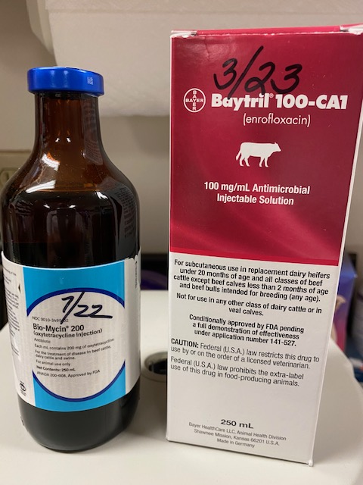

- What can you do to help a cow survive Theileria?
- Minimize stress, isolate the sick animal in a place conducive to Tender! Loving! Care!

- Provide the best quality nutrition possible in convalescence.

- There are no approved treatments in the U.S., however, we have had some patients survive with 5 days of tetracycline at the labeled dose, use a NEW needle each time, as it can be spread through blood.

- Supplements like daily Vitamin B complex are often helpful.

- Place fly spray on the cow to help combat external parasites.
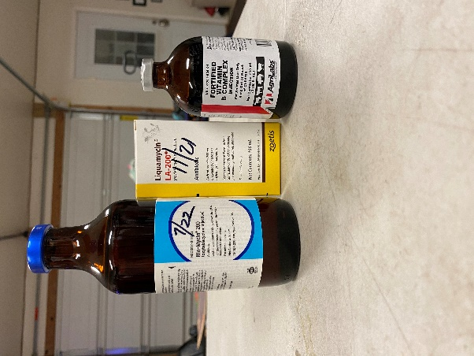

- How do I know if I have it in my herd?

- Blood testing can be done on live cattle using a purple top blood tube for Theileria and Anaplasmosis. Vet will send to the College of Veterinary Medicine at Virginia Tech ($45/sample).

- On a recently deceased animal the spleen can be removed and sent to Virginia Tech for the same Theileria and Anaplasmosis test.

- What do I do when I find out I have it in my herd?
- Know that you are not alone, this disease spreads through a county very quickly, usually within 1-2 weeks.

- Work with your veterinarian to decide what strategy is going to work best for your operation to help you get through this battle.

- Know that the first year of this disease is the worst and eventually it will become endemic in your herd; cattlemen who have struggled with this disease in 2017 say each year is less devastating.

- What tick control strategies can I use to combat this?

- The tricky part of this disease is remembering that when you have dead cows or calves, the tick bite probably came 4-6 weeks earlier.

- Unfortunately, for these fall calving cows, 4-6 weeks before the sick cows for most farms was around the middle of August, which is when the fly tags placed during Spring herd work would have expired.

- Another tough pill to swallow is that these ticks get on the underside of the cattle, in their elbows and groins…the places where it would be extremely difficult to see them or spray them.

- So…if you are seeing copious amounts of ticks in the environment and/or on the cattle try to get them identified to see if they are the Asian ticks. If so, the cattle will need to be injected with Ivomec, Dectomax, or Cydectin, or sprayed vigorously with Permethrin every 10-14 days. This can be challenging for grazing cattle in late pregnancy!

- If you aren’t seeing many ticks around August 1st you should either start an aggressive spraying regimen with permethrin, or perhaps inject the cattle with a long-acting ivermectin, like Long Range, which will last 2-3 months in their systems. It is VERY important to minimize stressful handling of pregnant cattle in the summer heat!

- Another strategy would be to make sure you contact your veterinarian in early Spring to get a six month prescription (VFD) for mineral medicated with CTC. The most important time to feed the tetracycline in the mineral is during season of external parasites. There is not enough CTC in the mineral to treat a tick-borne disease, it just aids in the prevention of tick-borne diseases. Important note: Several farms using medicated minerals still had affected animals.

- Finding a chemical that can work to control external parasites year after year is a challenge. It is important to rotate your fly tag chemicals by switching from Organophosphates or Permethrin based tags every 1-2 years.
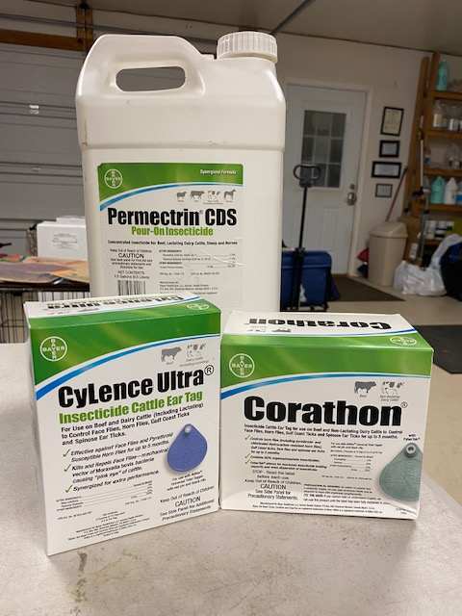

- Biosecurity concerns regarding Theileria

- Beware of bringing newly purchased animals into a group that has tick-borne diseases present. If these animals are naïve they may get sick and die from a lack of immunity. Some people are trying to replace cattle that have died over the past year, and I fully understand the need to do that. It might be better to purchase the cows with calves at side in a colder time of year, when the calves are larger.

- Also, many people will be bringing new bulls into their herds this year. Be sure you are not bringing a bull in with ticks on him. On the flip-side if a new bull comes into your herd that has been affected by Theileria and is not from an endemic region, his life may be in danger. I have seen bulls recover from the disease, but you need to closely check the bull for the first 4-6 weeks after arrival and be able to recognize the disease quickly.

- Quotes from producers affected by Theileria

- “Another dead cow tonight, this one had a 3 month old calf with no symptoms that I noticed. I’m starting to understand how my parents must have felt when their hog business was struck by hog cholera.” -Mary Hawkins, Madison County, VA

- “I have found your herd will build resistance from this disease. Be careful introducing naïve cattle into your herd 4-6 weeks before a stressful period, such as calving.” –Steve Hopkins, Louisa County, VA

- “My herd was first affected by this disease in 2018 when I watched a big bull go from bucking around in the field to 2 weeks later being so weak he could barely stand…I could even see weakness in his eyes. The key is checking your cows well and catching it early. You too can get through this.” -Mike Maupin, Albemarle County, VA

- “The symptoms are sort of strange, it started out as a dead cow, then stillborn calves, then some of the survivors developed some lameness.” -Evan Bowman, Greene County, VA

- “I think this disease has the potential to have the most devastating economic impact on the state’s cattle industry since Bang’s disease did in my father’s generation.” -James Kean, Louisa County, VA

- Through a beef producer’s eyes…

- In mid-April, I observed cows in one of my two herds with bloody necks and realized upon closer inspection, that the majority of the neck, ears, udders, and tail head area were covered with ticks and blood (which was a results of rubbing the ticks against trees.) The water trough, where they had been drinking, was also covered by ticks.

We treated them with Clean Up II and it seemed to kill the confirmed Asian Longhorned Ticks on the cows, for a while. Though, three months later, I had to put down a 6-year-old cow that was a straggler during her pasture moves and had a low body condition score coming out of the winter.

Over the next month, we had seven aborted premature or stillborn calves. We also had two live calves (very small) die, both within 3-4 days after their birth. These calves were all born one full month before calving was due to begin.

Bloodwork on 4 of the dams who had lost their calves all tested positive for Theileria. Everyday, masses of ticks had to be removed from our UTV, and more often than not, one or two steps into a pasture would results in tens to hundreds of various sized ticks, some as small as a pin head, crawling up boots and pant legs.

Over the past couple of years, I had been noticing certain areas that tick presence was heavy (any moist areas, waiting to pounce from anything handing around ankle to knee level on animals and humans) but the cows seemed okay. Until this year…the tick population seemed to explode like a bomb!

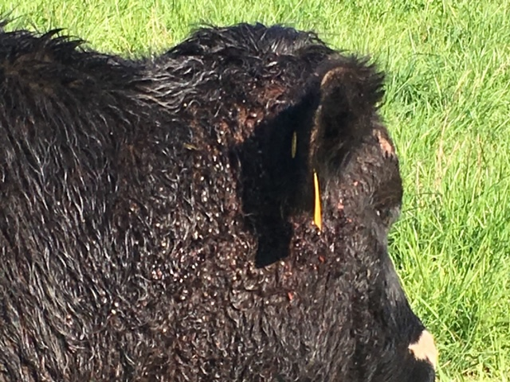

- My observations in battling this disease since 2017…

- Well-managed and poorly managed herds are at similar risk of getting this disease (it pains me to say that as a vet!). Herds with more aggressive culling procedures do seem to be having less deaths of adult cattle.

- Nearly every single cow that has been symptomatic and required veterinary treatment has tested positive for Theileria AND Bovine Leukosis Virus (BLV is the virus that can mutate to a kind of cancer that can cause lymphoma in cattle).

- In a herd in which one animal tests positive, nearly all of the cattle tested will test positive (whether they appear sick or not). I do try hard as a vet to be economically responsible when deciding how many animals in a herd should be tested.

- Theileria seems to affect the very young, compromised calves and the geriatric cattle the worst. It also preys on the cows that are recently post-partum because their immune system is compromised at this time.

- After evaluating groups of cows that were known to have lost calves in a calving season, I have seen Theileria be a main reason in Central Virginia for calf loss (whether it was abortion, stillborn, or weak to the point of dying shortly after birth). There are many other reasons for abortions/still births that should be considered including Leptosporosis, Neospora, Anaplasmosis, and/or BVD, to name a few.

- In conclusion, this is a very frustrating disease for all of us! We need to know the signs and symptoms, talk to other farmers in other areas about the disease, and continue to have good herd health management strategies in place. I especially encourage you to work closely with your veterinarian to help with ID of the tick, diagnosing the disease, treating sick animals, formulating a strategy to fight this battle going forward including external parasite recommendations, nutrition, and preventative health care for the herd. Hang in there and know that better times are ahead!

- If anyone is interested in having a “Theileria Support Group,” or a meeting to discuss strategies to battle the disease we at LVS would be happy to help you put that together (probably at a bar). Although, it would probably be better if we do that after our own pandemic is over!

- Also, if anyone is interested in participating in any research trials regarding Theileria, please contact Dr. Kevin Lahmers at the Virginia-Maryland College of Veterinary Medicine at klahmers@vt.edu.

- This information was compiled by Dr. Melinda McCall of Louisa Veterinary Service, with the help of Dr. Kevin Lahmers, Dr. Karen Hulebak, and some of my wonderful clients who were willing to share their experiences to help others.

